Chinese Bioscience Association (CBA) Event

Mitigating Future Financial Uncertainties
with Current Planning

Date: | March 19th, 2016 Saturday
Venue: | Oshman Family Jewish Community Center  Meeting Room E104 (Direction & Site Map)
Address: | 3921 Fabian Way, Palo Alto, CA, 94303
1:30 - 2:00 pm | Registration | Refreshment
2:00 - 3:30 pm | Facilitated Speech & Discussion
3:30 - 4:00 pm | Q&A
Speakers:
2:00–2:30 pm Investment Strategies during Volatility
Kai Chen, CFA
Founder & Managing Director, OceanIQ Capital
2:30–3:00 pm Taming the Bear Market
Stephen Koh, CLF
Vice President, MassMutual Northern California
3:00–3:30 pm Personal Lessons for Financial Planning
Bill Choy, PhD
Pharmaceutical Director, ZC2 Consulting
Moderator:
Frank Zhou, PhD

Registration:
CBA Alliance:
Online registration: Free
Please copy and past the link: [https://www.eventbrite.com/e/mitigating-future-financial-uncertainties-tickets-23006567262]
On-site registration: $5

Organizers:

Our Speakers:

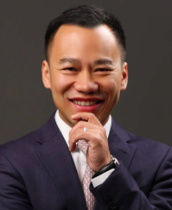
Kai Chen, Chartered Financial Analyst (CFA). Kai is the Founder & Managing Director of OceanIQ Capital. He started his investment management career at Goldman Sachs Private Wealth Management, specializing in asset allocation and investment strategies. He later spent 12 years at Credit Suisse and was most recently a Director and Relationship Manager. Kai graduated from UCLA with a BA in Business Economics. He currently sits on the board of FLY (Fresh Lifelines for Youth), a non-profit dedicated to serving at-risk youth.
Investment Strategies during Volatility: How do we face market volatility and keep our goals focused and clear?

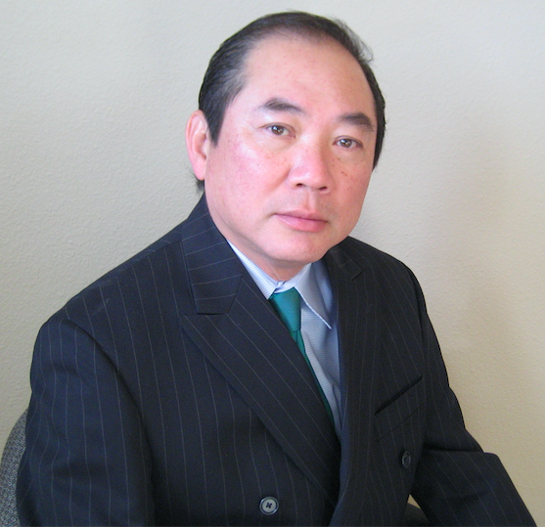
Stephen Koh, Chartered Leadership Fellow(CLF), currently Vice President with MassMutual Northern California. 30 years of extensive experience in developing and managing top investment and insurance professionals in the financial service industry. Educated in UK and the US, Stephen Koh taught as adjunct faculty at College of Business and Economics, CSUEB.

Taming a Bear Market in Retirement: What should we do now and future in preparing for the negative impact of a bear market during retirement years?

Bill Choy, Ph.D., MBA, ZC2 Consulting/pharmaceutical director. Bill got his BS at UC-Berkeley, PhD at UC-Santa Cruz, was a post-doc at MIT and got his MBA from Santa Clara University's executive MBA program. His industrial career started in 1990 at Genelabs Technologies (now part of GSK). His current consulting career started in '00 as a retained consultant for Genovate Biotech (Taiwan's 1st biotech company) and focusses on selecting in-vitro/in-vivo protocols, designing clinical protocols and strategic marketing research. Among his recent clients are entrepreneurs starting-up drug discovery companies in China
Personal Lessons for Financial Planning: As a victim of the last (ongoing?) recession, I learned a lot from simple mistakes many Americans have made for/in their retirement planning and want to share with you my perspectives on financial planning

